DTS-ESB
GPS Online Proxy Service

System Design Specifications

Version 0.1.6

Revision History
Date (mm/dd/yy) | Version | Description | Author
09/17/13 | 0.0.1 | Draft Version | Chahid Benamar
09/18/13 | 0.0.2 | Updated the sections for more details | Rekha MS
09/20/13 | 0.0.3 | Added Diagrams | Raiju Mathew
09/20/13 | 0.0.4 | Updated Diagrams and Tables and explanation | Raiju Mathew, Rekha MS
09/23/13 | 0.0.5 | Added new diagrams and incorporated review comments from Chahid, Kais, Kumar and Rekha | Raiju Mathew
09/24/13 | 0.0.6 | Added new diagrams and explanations. Changed the Proxy service configuration table structure | Raiju Mathew, Rekha MS
10/01/13 | 0.0.7 | Updated as per comments from Chahid | Rekha MS
10/03/13 | 0.0.8 | Updated GPS Online Proxy WSDL | Rekha MS
10/16/13 | 0.1.1 | Updated for review Comments and GPS Online Proxy WSDL | Rekha MS
11/05/13 | 0.1.3 | Updated section 3.2.2, 3.1.1, 3.1.2 and 4.1 | Rekha MS,Syed K
11/05/13 | 0.1.4 | Updated according to comments | Chahid Benamar
11/08/13 | 0.1.6 | Updated diagrams and added note for ESB009 in section 2.2.6 | Rekha MS
11/08/13 | 1.0.0 | Review | Chahid Benamar
Table of Contents
1. Introduction 4
1.1 Scope 4
1.2 Definitions, Acronyms and Abbreviations 4
1.3 References 4
1.4 Overview 5
1.5 Tools and APIs 5
2. Logical View 5
2.1 GPS Online Proxy Service/Functions Model 5
2.2 GPS Online Proxy Service Processes 6
2.2.1 GPS Online Proxy Service Oriented Architecture and Design 6
2.2.2 GPS Online Proxy Service Process Diagram 7
2.2.3 GPS Online Proxy Service Authentication Process 8
2.2.4 GPS Online Proxy Service Payload Validation Process 8
2.2.5 GPS Online Proxy Service Selective Detokenization Process 8
2.2.6 GPS Online Proxy Service Selective Processor Routing Process 10
2.3 GPS Online Proxy Service Response Flow 11
3. GPS Online Proxy Service Structure 11
3.1 GPS Online Proxy Service Components 12
3.1.1 GPS Online Proxy Service 12
3.1.2 GPS Online Business Service 13
3.1.3 GPS Online XQueries and XPaths 14
3.1.4 GPS Online Proxy WSDL 15
3.2 GPS Service Interface 15
3.2.1 GPS Service Request 15
3.2.2 GPS Service Response 17
4. Annexe: 18
4.1 DTS-ESB error Codes 18

System Design Specification

Introduction

To improve the current credit card payment architecture to provide more flexibility, a new system called Generic Payment Service (GPS) is created. GPS is designed to make credit card payment related systems and processes independent from the credit card payment vendor’s specificities. It has the capability for seamless use of more than one credit card payment vendor at a time and it limits the future impact of change of credit card payment vendors.

A new service called DTS-ESB GPS Online Proxy Service (GPSTransCC service) is added to existing DTS-ESB platform in order detokenize and forward the requests from GPS to the target payment gateway.

This System Design Specifications document provides a complete overview of the DTS-ESB GPS Online Proxy Service and its components. This document also provides a complete understanding of the functionality of DTS-ESB GPS Online Proxy Service.

Scope

The DTS-ESB GPS Online Proxy Service is designed accept all the credit card transactions forwarded from GPS. Since these credit card numbers will be in the form of tokens, they have to be de-tokenized before sending them to the processor for certain transaction types. In such cases, DTS-ESB GPS Online Proxy Service should make a DTS detokenization call and should replace the token in the request payload, with the corresponding PAN fetched from DTS. Later it should route the transaction to appropriate payment gateway vendor.

This document describes the design specification for the new DTS-ESB GPS Online Proxy Service (GPSTransCC Service) in existing ESB environment.

Definitions, Acronyms and Abbreviations
PCI | Payment Card Industry
DSS | Data Security Standard
DTS | Data Tokenization System
SOA | Service Oriented Architecture
GPS | Generic Payment Service
ESB | Enterprise Service Bus
OSB | Oracle Service Bus
XML | eXtensible Markup Language
CSV | Comma Separated Values
FL | Fixed Length
NVP | Name Value Pair
CDE-DMZ | Cardholder Data Environment de-Militarized Zone

References
The following documents are used as reference:

GPS_SRS_V1.1_INTERNAL_Final.doc | The System Requirements Specifications
eSELECTplus_XML_DTD_Field_Definition.pdf | Merchant Integration Guide Transaction DTD v.1.1.7
eSELECTplus_Java_IG.pdf | Merchant Integration Guide Java API v 1.2.3
Requirements Tracking Matrix v0 1.xls | The requirements Matrix

Overview
This System Design Specifications (SDS) document addresses the various technical requirements for the DTS-ESB GPS Online Proxy Service. The SDS will also provide a detailed design picture of the new OSB Services that will be added to the existing DTS-ESB OSB platform and will illustrate the interaction between GPS, DTS-RTS interfaces and the third party Payment Gateways applications with the DTS-ESB GPS Online Proxy System.
.

Tools and APIs
- Oracle Weblogic application server version 10.3.4
- OSB 11g R1 (11.1.1.4.0) PS4
- Eclispse OEPE 3.6.1 (OSB Eclipse Platform)

Logical View

GPS Online Proxy Service/Functions Model
The following highlights the DTS-ESB GPS Online Proxy service/functions and its interaction with GPS, DTS-RTS and third party Payment Gateways:

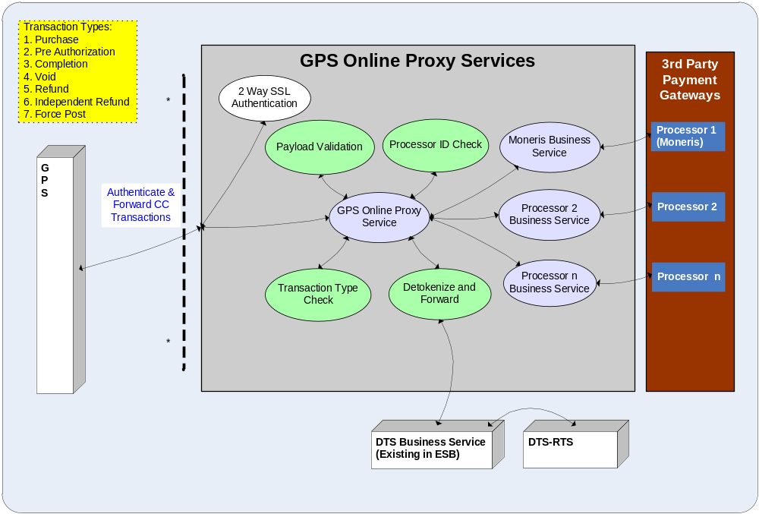

Notes:
- A 2-Way SSL Authentication will be configured between GPS System in ICN and GPS Online Proxy System in CDE-DMZ at Oracle OSB level. Also, an authorization will be performed to allow only predermined BSSs. See section 2.2.3 for more details.
- Only Schema validation will be performed and no content level validation will be done by GPS Online Proxy System.
- Only four transaction types, Purchase, Pre Autherization, Independent Refund and Force Post need de-tokenization flow to DTS-RTS.
- Proxy service will decide which Processor to forward the request based on the information present in the payload.

GPS Online Proxy Service Processes
This section explains all the processes of the GPS Online Proxy services.

GPS Online Proxy Service Oriented Architecture and Design
The GPS Online Proxy Service has been designed based on a Service Oriented Architecture approach and featured to be deployed in Oracle Service Bus.

Oracle Service Bus is a proven, lightweight and scalable SOA integration platform that delivers low-cost, standards-based integration for high-volume, mission critical SOA environments. It is designed to connect, mediate, and manage interactions between heterogeneous services, legacy applications, packaged applications and multiple enterprise service bus (ESB) instances across an enterprise-wide service network.

Proxy services are a fundamental concept in the architecture of Oracle Service Bus. They are the interface that service consumers use to connect with managed back-end services. Proxy services are definitions of intermediary Web services that the Service Bus implements locally. Oracle Service Bus Console allows configuration of a proxy service by defining its interface in terms of Web Services Description Languages (WSDLs) and the type of transport it uses. Message processing logic is specified in message flow definitions when defining a proxy service.

Business services are Oracle Service Bus definitions of the enterprise services that exchange messages during business processes. A business service and its interface can be defined and configured using the Oracle Service Bus Console. To configure a business service you must specify its interface, type of transport it uses, its security requirements, and other characteristics.

GPS Online Proxy Service Process Diagram

Following diagram describes the overall component interaction diagram of GPS Online Proxy Service.

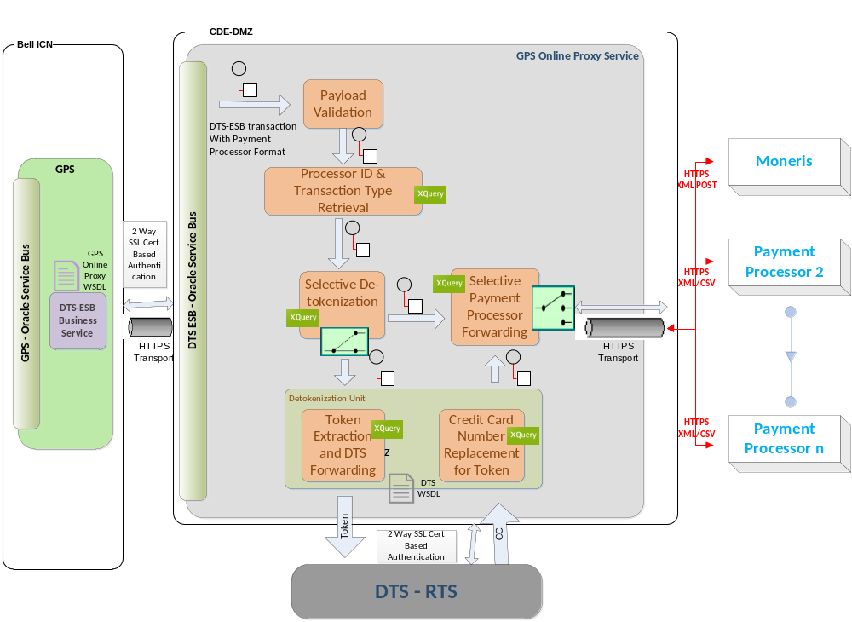
Notes:
- The DTS-ESB Oracle Service Bus, which hosts the GPS Online Proxy Service, interacts with the GPS in the front end using HTTPS protocol. Authentication is done by 2 way SSL handshake. The configuration for the SSL authentication is set at OSB level.
- The GPS Online Proxy Service receives the payload from GPS. The payload is expected to be already formatted specific to the target payment gateway processor. No payload transformation other than the token replacement, if required, is done at GPS Online Proxy Service. The different payload formats are XML, CSV. For Moneris, the payload for online transaction is in XML format.
- The payload will be validated first. Then ProcessorID and Transaction Types are retrieved from the request. Depends on the transaction type, whether to go for de-tokenization or simply forwards the request to the processor, will be decided.
- If detokenization is needed, token from payload needs to be retrieved. Token position in payload may vary depends on the Transaction Type and target Processor ID. So appropriate XQuery needs to be run to retrieve the token. Token will be sent to DTS for detokenization. The resultant PAN from DTS will be placed in the payload in the place of token.
- Depends on the target Processor ID, the appropriate business service for that processor will be called to complete the transaction.

GPS Online Proxy Service Authentication Process

The GPS Online Proxy Authentication consists of 2-Way SSL certificate configurations in Oracle Service Bus level. The OSB ensures that only the trusted requests will be received by the GPS Online Proxy Service for further processing.

The Entrust Advantage Certificate of GPS should be added to the keystore of Oracle Service Bus of GPS Online Proxy in order to identify and trust the GPS requests. Also Entrust Advantage Certificate of GPS Online Proxy should be added to the keystore of Oracle Service Bus of the GPS in order to facilitate the 2 way trusting.

If 2-Way SSL certificate authentication fails, the request will not even reach the GPS Online Proxy Service. In this case it is up to the GPS System to handle the SSL failure error.

GPS Online Proxy Service Payload Validation Process
The following diagram depicts the Payload Validation Process flow for GPS Online Proxy Service.

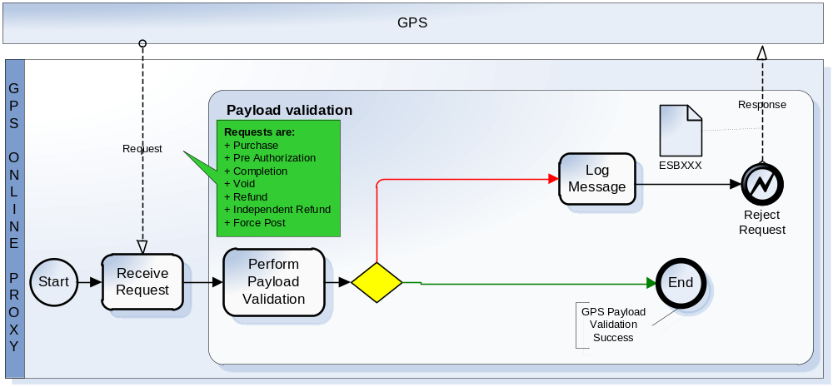

If the payload is XML, only the Schema validation will be performed using a ‘validate node’ in GPS Online Proxy OSB. If schema validation fails, GPS Online Proxy Service will log the failed request using the log node of OSB and will return ESB001 to the GPS. If the validation is successful, it will proceed to the next stage.

GPS Online Proxy Service Selective Detokenization Process

The following diagram depicts the Selective Detokenization Process flow for GPS Online Proxy Service.

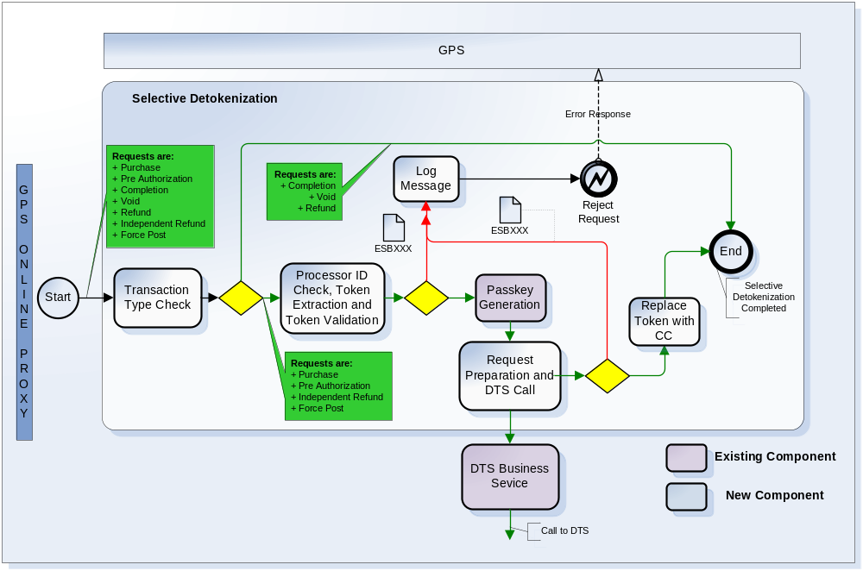

The Transaction Type Check stage will check if the transaction is one among the following 4 types.

- PURC (Purchase)
- PAUT (PreAuthorizaion)
- INDR (Independent Refund)
- FPST (ForcePost)

If the transaction type is one of the above four, a detokenization is needed for the token present in the payload. This is achieved by sending the detokenization request to DTS-RTS. It includes fetching the token from the payload, validating the token, generating the passkey and preparing the DTS-RTS request as per DTS WSDL and sending the request to existing DTS Business Service in ESB. It is the DTS Business Service which will contact the DTS-RTS System.

DTS-RTS Request Mapping:

The below table illustrates the DTS-RTS Request preparation:

SI NO | DTS-RTS Request | GPSOnlineProxy Request
 | dtsServiceRequest/requestHeader /consumerID | “esb”
 | dtsServiceRequest/requestHeader/ applicationID | “esb”
 | dtsServiceRequest/ requestHeader /systemTransactionID | TransCCRequest/HeaderRequest/ BSSTransID
 | dtsServiceRequest/ requestHeader /userID | “TransCCRequest/HeaderRequest/ ApplicationID”-“ TransCCRequest/HeaderRequest/ BSSID”  Example: GPS-NM1
 | dtsServiceRequest/ requestHeader /passkey | Passkey generated from getDTSPassKey java Callout to existing DTSPassKey Jar

Upon receinving the DTS-RTS response, perform the response validation and replace the token in the GPS payload with the Credit Card number from DTS-RTS.

Any error found when communicating with DTS or on De-tokenization error will be returned in the GPS Online Proxy Response.

GPS Online Proxy Service Selective Processor Routing Process

The following diagram depicts the Selective Processor Routing Process flow for GPS Online Proxy Service.

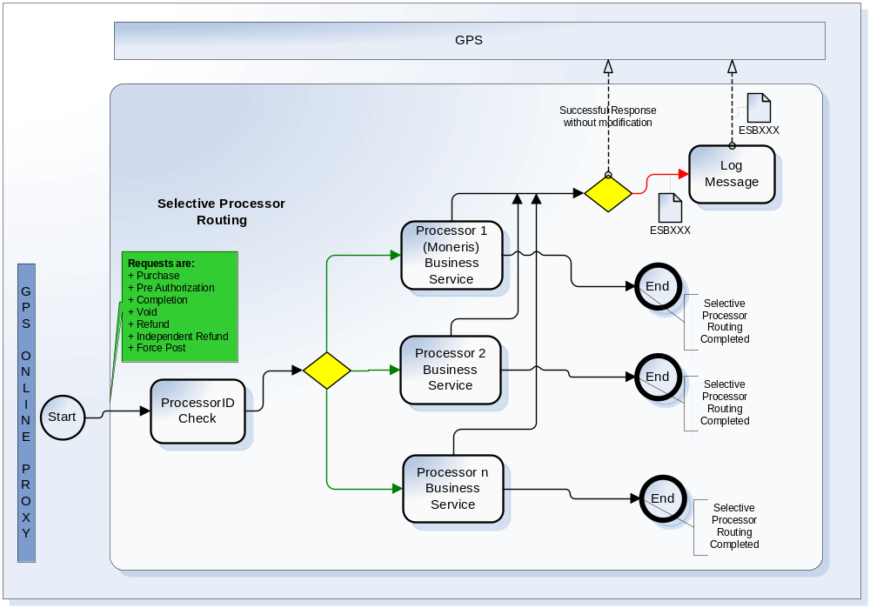

The Processor ID will be supplied by the GPS within the request. If it is Moneris’s ID, route the request to the Moneris Business Service. The Processor ID will decide on which processor business service should be called in order to forward the request.The business service will in turn call the specific Processor system associated with it.

In any case, if the processor business service fails to connect to the third party processor system, the GPS online Proxy returns ESB006 as the response to GPS. In that case GPS online Proxy should also log necessary details about the failed transaction.

All the response from Processor System, whether successful or unsuccessful, should be returned to the GPS as it is.

In any case, GPS Online Proxy should not log the PAN number, if present in the payload.

Note: GPS Online Proxy Service is designed to selectively forward requests to the Payment Processors depending on the ProcessorID in the request.As of now, Moneris is the only allowed Processor for GPS Online Proxy Service. For any other Processor in the request, GPS Online Proxy Service returns ESB009-“ ProcessorID is not recognized” System error.

GPS Online Proxy Service Response Flow

In the payment gateway response flow, GPS Online Proxy Service acts as a simple passthrough system. The processor response will be sent as it is to the GPS System, meaning no processing or modification will be done at GPS Online Proxy Service level.

The GPS Online Proxy service allows a maximum of 4 seconds for receiving the credit card payment processor response before timing out. The timeout set also to communicate with DTS-RTS is 4 seconds as well.

This is set in the Processor( example Moneris) Business Service configuration Read timeOut as shown in section 3.1.2

GPS Online Proxy Service Structure
The following section shows the structure of the GPS Service.

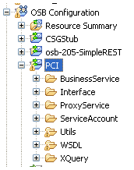

- PCI\BusinessService: This folder contains Moneris Business Service.
- PCI\ProxyService: This folder contains GPS Proxy Service.
- PCI\Interface: This folder contains the schemas. Not used for GPSTransCC Service.
- PCI\ServiceAccount: This folder contains username and password details required for basic authentication. Not used for GPSTransCC Service.
- PCI\Utils: This folder contains the jars containing java classes used in Java CallOut in Proxy Service. Not used for GPSTransCC Service.
- PCI\WSDL\GPS: This folder contains the WSDL used by GPS Service and schemas referenced by the WSDL.
- PCI\XQuery: This folder contains XQuery mapping to select the token from payload and insert the creditcardnumber for the GPS Service

GPS Online Proxy Service Components

GPS Online Proxy Service

Service | Proxy service to process Credit Check transactions between GPS and Processor, with ability to de-tokenize credit card information if necessary
Backend service triggered | DTS web service  Moneris XML / HTTPS POST
Accessed by | GPS
Functionalities | Invoke DTS Web Service to de-tokenize credit card token input (if provided)  Invoke Moneris Web Service for the Credit Card Transactions

Project and directory structure: This service is going to be created under OSB in the following directory:

PCI/ProxyService

Configuration Details:

Proxy Service Configuration (PCI/ProxyService/GPS)
General Configuration
Service Type | Web Service - SOAP 1.1 (WSDL:PCI/WSDL/GPS/GPSTransCC, port=" GPSServicePort")
Transport Configuration
Protocol | http
Endpoint URI | /PCI/GPS
Get All Headers | No
Headers
HTTP Transport Configuration
HTTPS required | Yes
Authentication | Client Certificate
Operation Selection Configuration
Enforce WS-I Compliance | No
Selection Algorithm | SOAP Body Type
Message Handling Configuration
Transaction Required | Disabled
Content Streaming | Disabled
XOP/MTOM Support | Disabled
Page Attachments to Disk | No

Notes:
Authentication is 2- way SSL Authentication between GPS and DTS-ESB

GPS Online Business Service
There will be separate GPS Online Business Service for each processor. For each Processor System added in the future, corresponding new business service also will be introduced in the GPS Online Proxy Service.

Below given is the Moneris Business Service details and this is the only one processor identified so far.

Service | Moneris Business Service
Backend service/API triggered | Moneris Web Service
Accessed by | GPS Online Proxy Service
Functionalities | The new business service will be consumed by GPS Online Proxy service to send credit card payment information to the Moneris for different credit card payment transactions

Project and directory structure: This service is going to be created under OSB in the following directory:

PCI/BusinessService

Configuration Details:

Business Service Configuration (PCI/BusinessService/Moneris)
General Configuration
Service Type | Any XML Service
Transport Configuration
Protocol | http
Load Balancing Algorithm | None
Endpoint URI | https://esqa.moneris.com/mpg/
Retry Count | 0
Retry Iteration Interval | 0
Retry Application Errors | No
HTTP Transport Configuration
Read Timeout | 4
Connection Timeout | 4
HTTP Request Method | POST
Authentication | None
Proxy Server | N/A
Follow HTTP redirects | Enabled
Use Chunked Streaming Mode | Disabled
SOAP Binding Configuration
Enforce WS-I Compliance | No
Message Handling Configuration
XOP/MTOM Support | Disabled
Page Attachments to Disk | No
Result Caching | Not Supported

Note : for the DTS timeout, we will reuse the exiting setting as below:

HTTP Transport Configuration
Read Timeout | 0
Connection Timeout | 10

GPS Online XQueries and XPaths

XPath:

The Xpath is a way of locating specific elements in an XML tree. In GPS Online Proxy Service, we use the below XPaths to locate ProcessorID and Transaction Type from the GPS payload.

Element | XPath
ProcessorID | TransCCRequest/ProcessorInfo/ProcessorID
TransType | TransCCRequest/ProcessorInfo/TransType

XQuery:

XQuery is an XML functional query language that makes use of XPath to query XML structures. In GPS, we use XQuery to locate the token present in the GPS payload because the position of the token may vary depends on the Transaction Type. The position specific to the processor payload format.

For Moneris, the payload format is XML for online transaction. Given below are the different XPaths to locate the token from GPS payload for the Moneris for all four applicable transactions types PURC, PAUT, INDR and FPST. The Xquery to extract token from GPS Moneris payload will use one of these Xpaths, internally, based on the Transaction Type used.

Transaction Type | XPath
PURC | TransCCRequest/ProcessorInfo/ProcessorRequest/request/purchase/pan
PAUT | TransCCRequest/ProcessorInfo/ProcessorRequest/request/preauth/pan
INDR | TransCCRequest/ProcessorInfo/ProcessorRequest/request/ind_refund/pan
FPST | TransCCRequest/ProcessorInfo/ProcessorRequest/request/forcepost/pan

Note:
- All 4 transaction types listed above trigger the DTS detokenization. The PAN from the DTS response should be extracted and the token in the GPS Moneris payload should be replaced with the it.
- The same Xpaths given above can be used to replace the token with the PAN.

GPS Online Proxy WSDL

GPS Online Proxy WSDL exposes a single operation called “ForwardCCTrans”.

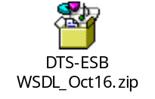

GPS Service Interface

GPS Service Request

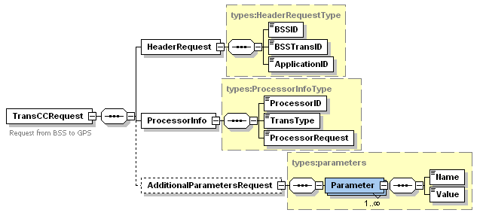

The following table contains sample request structure for the GPS Online Proxy.

<soapenv:Envelope xmlns:soapenv="http://schemas.xmlsoap.org/soap/envelope/" xmlns:mes="http://ESB.int.bell.ca/GPS/messages" xmlns:typ="http://ESB.int.bell.ca/GPS/types">
<soapenv:Header/>
<soapenv:Body>
<mes:TransCCRequest>
<mes:HeaderRequest>
<typ:BSSID>VirginWeb</typ:BSSID>
<typ:BSSTransID>123</typ:BSSTransID>
<typ:ApplicationID>GPS</typ: ApplicationID>
</mes:HeaderRequest>
<mes:ProcessorInfo>
<typ: ProcessorID>Moneris</typ: ProcessorID>
<typ:TransType>PURC</typ:TransType>
<typ: ProcessorRequest><![CDATA[<?xml version="1.0" encoding="UTF-8"?><request>
<store_id>your_store_id</store_id>
<api_token>your_api_token</api_token> // MerchantID
<purchase>
<order_id>unique_order_id</order_id>
<cust_id>cust_info_1</cust_id>
<amount>1.00</amount>
<pan>4242424242424242</pan>
<expdate>1412</expdate>
<crypt_type>7</crypt_type>
<avs_info>
<avs_street_name>Main St</avs_street_name>
<avs_zipcode>M1M1M1</avs_zipcode></avs_info>
<cvd_info>
<cvd_indicator>1</cvd_indicator>
<cvd_value>123</cvd_value>
</cvd_info>
</purchase>
</request>]]></typ:ProcessorRequest>
</mes: ProcessorInfo>
<mes:AdditionalParametersRequest>
<!--1 or more repetitions:-->
<typ:Parameter>
<typ:Name>aaaaaaaaa</typ:Name>
<typ:Value>aaaaaaaaa</typ:Value>
</typ:Parameter>
</mes:AdditionalParametersRequest>
</mes:TransCCRequest>
</soapenv:Body>
</soapenv:Envelope>

GPS Service Response

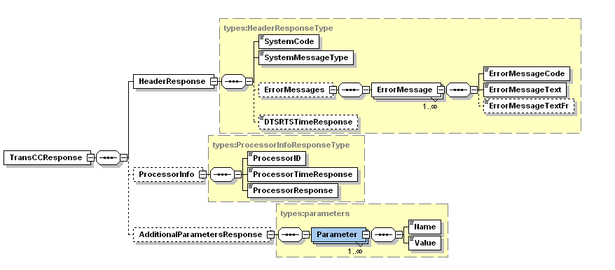
<SystemCode>ESB-0006
<ErrorMessage>
<ErrorMessageCode>
Backend service has returned an unexpected error - <System Name>Service - <code>::<message>

The following table contains sample response structure for the GPS Online Proxy.

<soapenv:Envelope xmlns:soapenv="http://schemas.xmlsoap.org/soap/envelope/"
xmlns:mes="http://ESB.int.bell.ca/GPS/messages" xmlns:typ="http://ESB.int.bell.ca/GPS/types">
<soapenv:Header />
<soapenv:Body>
<mes:TransCCResponse>
<mes:HeaderResponse>
<typ:SystemCode>0</typ:SystemCode>
<typ:SystemMessageType>Success</typ:SystemMessageType>
<typ: DTSRTSTimeResponse>250</typ: DTSRTSTimeResponse>
</mes:HeaderResponse>
<!--Optional: -->
<mes:ProcessorInfo>
<typ:ProcessorID>0</typ:ProcessorID>
<typ:ProcessorTimeResponse>250</typ:ProcessorTimeResponse>
<typ:ProcessorResponse><![CDATA[<?xml version="1.0" encoding="UTF-8"?>
<response>
<receipt>
<ReceiptId>9991210999</ReceiptId>
<ReferenceNum>660110910011124090</ReferenceNum>
<ResponseCode>027</ResponseCode>
<ISO>01</ISO>
<AuthCode>739357</AuthCode>
<TransTime>06:23:06</TransTime>
<TransDate>2013-10-29</TransDate>
<TransType>00</TransType>
<Complete>true</Complete>
<Message>APPROVED * =</Message>
<TransAmount>13.00</TransAmount>
<CardType>V</CardType>
<TransID>222743-0_9</TransID>
<TimedOut>false</TimedOut>
<BankTotals>null</BankTotals>
<Ticket>null</Ticket>
<CorporateCard>false</CorporateCard>
<IsVisaDebit>false</IsVisaDebit>
</receipt></response>]]>
</typ:ProcessorResponse>
</mes:ProcessorInfo>
</mes:TransCCResponse>
</soapenv:Body>
</soapenv:Envelope>

Annexe:

DTS-ESB error Codes
The table bellow summarizes the DTS-ESB error codes.

 | System Code | System Message Text | Error Message Code | Error Message Text | Scenario / Conditions
1 | 0 | Success | - | - | The transaction has been treated successfully.
2 | 2 | System Error | ESB001 | Invalid Request-Schema validation failed. | Client is trying to access the service with invalid request. Schema validation failed.
3 | 2 | System Error | ESB002 | Backend Service Unavailable - <System Name> Service :: <message> | Either DTS service or Moneris Service is down or unreachable  The message text will be appended with the System name (DTS / Moneris) and fault information resulting from the failed connection (timeout or connection rejection)
4 | 2 | System Error | ESB003 | Error processing back end response – <System Name> Service | DTS / Moneris returns a response that does not conform to its schema definition
5 | 2 | System Error | ESB004 | Proxy service unexpected error | Unknown, unexpected error occurred within the ESB internal processing
6 | 2 | System Error | ESB005 | Proxy service invalid data: Request contains invalid token (meaning token is not starting with 7, 8 or 9)  Proxy service invalid data. | If proxy service contains invalid data and request cannot be forwarded to provider (i.e. Invalid Token). Error message “Proxy service invalid data: Request does not contain Creditcard information within Payment or invalid token“will be returned.
7 | 2 | System Error | ESB006 | Backend service has returned an unexpected error - <System Name>Service - <code>::<message> | Backend Service has returned an unexpected error  The message text will be appended with the name of the backend service and the error code/message coming back from the backend.
8 | 2 | System Error | ESB007 | Backend Service Unavailable - DTS Service - <code>::<message> | DTS service is down or unreachable  The message text will be appended with the fault information resulting from the failed connection (timeout or connection rejection)
9 | 2 | System Error | ESB009 | ProcessorID is not recognized - <ProcessorID> | Incoming XML has a processor ID that is not recognized.

Note: Any Error returned from Moneris will be returned as it is to the Calling System.

